# Project Design Phase-I Solution Architecture

|  |  |
| --- | --- |
| Date | 19 September 2022 |
| Team ID | PNT2022TMID04866 |
| Project Name | Inventory Management System for Retailers |
| Maximum Marks | 4 Marks |

**Solution Architecture:**

Solution architecture is a complex process – with many sub-processes – that bridges the gap between business problems and technology solutions. Its goals are to:

* Retailers can access the application to display and sell their products to customers.
* Users can log in to their account using their credentials. The application fetches their customer details and allows them to continue where they left off and have the products in the list of which they added to purchase.
* We are containerizing the application using IBM Db2 database and deploying in IBM Cloud which is highly scalable for optimizing and as well as improving anything in the future easily.
* Sales prediction is done by using machine learning to predict which products are most likely to be ranked high for selling and thus retailers can contact their suppliers in advance to restock their products.

# Solution Architecture Diagram:

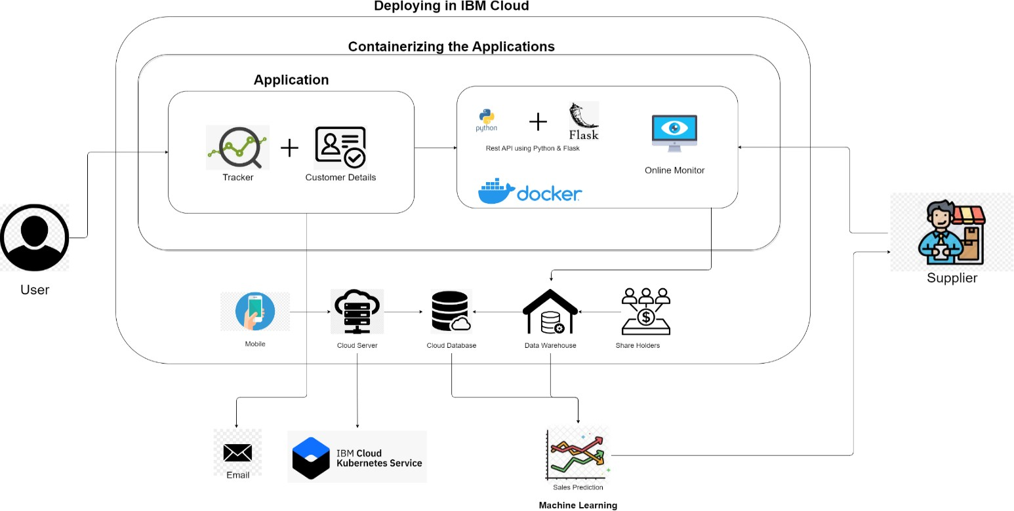

*Figure 1: Architecture and data flow for inventory management system for retailers.*